**1.Introduction**

The Perishable Management System for Retail Stores, is a software solution designed to address the unique challenges faced by retail establishments dealing with perishable goods. Perishable items, including but not limited to food products, flowers, pharmaceuticals, and other time-sensitive commodities,require systematic management to maximize inventory efficiency, minimize product spoilage, uphold stringent quality standards, and ultimately elevate the financial performance of the business.

**1.1 Purpose**

* The primary purpose of this Software Requirements Specification (SRS) document is to provide a comprehensive and detailed outline of the functional and nonfunctional requisites, system attributes, and limitations that will govern the progression and integration of the Perishable Management System.
* It stands as a foundational point of reference for all key stakeholders, encompassing developers, project management personnel, quality assurance teams, and business analysts, fostering a shared comprehension of project aims and deliverables. This document plays a pivotal role in establishing clarity and alignment across the project spectrum.

**1.2 Scope**

The Perishable Management System's scope encompasses the following vital domains:

**Inventory Management:**

* This encompasses the efficient tracking, control, and replenishment of perishable item inventories at multiple retail store locations.

Demand Forecasting: Utilization of data-driven algorithms to predict demand patterns and optimize stock levels for perishable products.

Optimal Stock Levels: Maintain a lean inventory by ordering perishable goods based on demand.

**Supplier Collaboration:**

* This involves facilitating communication and data exchange with suppliers to maintain a seamless supply chain and ensure product availability.
* Good supplier relationships can result in better product quality and delivery reliability.

**Product Management:**

* Quality Assurance: Monitoring and ensuring the quality of perishable goods through the tracking of expiration dates, temperature conditions, and quality metrics.
* Using First-In, First-Out (FIFO): Implement the FIFO principle to ensure older products are sold before newer ones. This reduces the risk of items expiring on the shelves.
* Technology and Data Analytics:

Data Analysis: Leverage data analytics tools to gain insights into sales trends, customer preferences, and inventory turnover rates. Use this data to refine your strategies and make informed decisions.

POS Systems: Use point-of-sale systems to track sales, inventory, and customer behavior in real-time.

**Pricing Strategies**

* Dynamic pricing: Implementing dynamic pricing strategies to maximize revenue based on factors such as shelf life, demand, and competitive pricing.
* Dynamic Discounts: Implement dynamic pricing strategies that reduce prices as perishable goods approach their expiration dates. This encourages customers to buy them before they spoil, reducing wastage.

**Integration:**

* Seamless integration with existing retail systems, including Point-of-Sale (POS) systems and supply chain management software, to ensure data accuracy and consistency.

Dataflow diagram

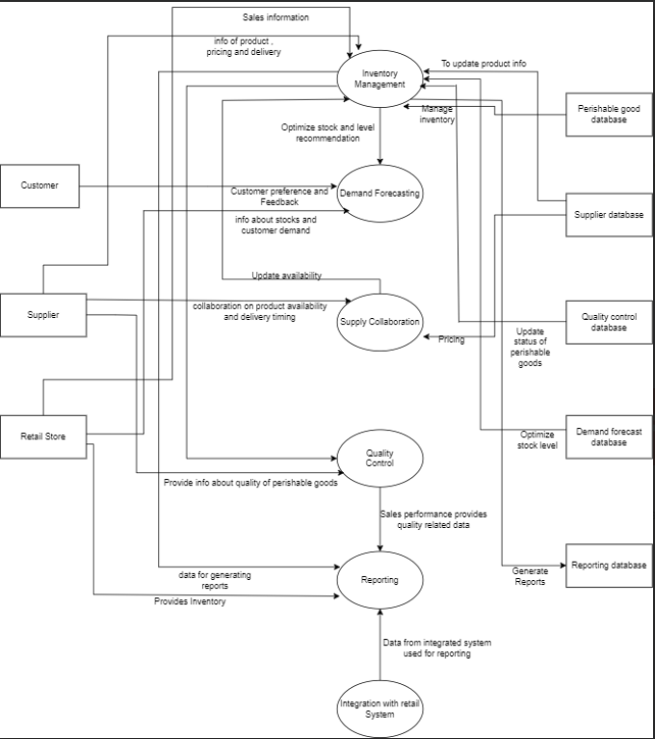

**1.3 Document References**

This section provides a list of external documents and resources that have been consulted during the development of the Perishable Management System SRS.

1. Inventory Management Tools for Perishable Goods

https://www.winman.com/blog/the-best-inventory-management-tools-for-perishable-goods

- This online resource offers insights into inventory management tools specifically designed for perishable goods, which have informed the design and functionality of our system.

2. A Taxonomy and Research Overview of Perishable-Asset Revenue Management

https://www.researchgate.net/publication/243767251_A_Taxonomy_and_Research_Overview_of_Perishable-Asset_Revenue_Management_Yield_Management_Overbooking_and_Pricing

- This research paper provides valuable insights into the concepts and strategies related to perishable-asset revenue management, including yield management, overbooking, and pricing. These insights have influenced the revenue optimization features of our system.

3. Proceedings of the Atlantis Press on Advanced Engineering and Management for Sustainable Society (AEMSS)

https://www.atlantis-press.com/proceedings/aemss-20/125941982

- This conference proceeding contains relevant information on advanced engineering and management, which has contributed to the development of sustainable practices within our perishable management system.

These references have played a significant role in shaping the design and functionality of our Perishable Management System and ensuring that it aligns with industry best practices and research in the field of perishable goods management.

**1.4 Document Structure**

This document is organized into several sections to provide a structured overview of the system requirements and features. These sections include:

- General Description

- Specific Requirements

- System Features

- Constraints

- Assumptions and Dependencies

- Risk Analysis

- Appendices

- Review and Approval

**1.5 Target Audience**

The SRS document serves as a critical reference for all stakeholders engaged in the Perishable Management System project. This includes developers, project managers, quality assurance teams, business analysts, and end-users.

**1.6 Document Ownership**

This SRS document is owned and maintained by Pearson Spectre ltd. . Any inquiries, feedback, or requests for changes should be directed to the document owner.

**1.7 Document Version Control**

This document is version-controlled, and any updates or revisions will be duly recorded and communicated to all relevant parties.

Version : 1.0

Date : 09-09-2023

Description : Initial Description

Author :Pearson Spectre ltd.

**2. Overall Description**

**2.1 Product Perspective**

The Perishable Management System (PMS) is designed to operate within a larger retail management ecosystem while providing essential functionalities for the efficient management of perishable goods. It serves as an integral component of the overall retail infrastructure, enhancing inventory control, demand forecasting, and supplier collaboration in the context of perishable items.

System Overview

The PMS is intended to streamline and optimize the management of perishable goods, including food products, flowers, pharmaceuticals, and other time-sensitive commodities. It operates in harmony with existing Point-of-Sale (POS) systems, supply chain management software, and other retail technologies.

System Boundaries

The scope of the PMS encompasses the entire perishable goods management process within our retail stores. It does not extend to non-perishable items or unrelated retail operations.

Data Flow

Data flows into the PMS from various sources, including supplier updates, customer transactions, and inventory databases. The system processes this data to facilitate demand forecasting, inventory control, and quality assurance.

System Architecture

The system follows a modular architecture, with components dedicated to inventory management, demand forecasting, supplier collaboration, quality assurance, and pricing strategies. This architecture allows for scalability and easy integration with existing retail systems.

**2.2 Product Functions**

The major functions of the Perishable Management System include:

1. Inventory Control:

- This function involves precise tracking, control, and replenishment of perishable item inventories. It ensures that the right amount of perishable goods is available at the right time to prevent overstocking or running out of items, minimizing waste and optimizing storage.

2. Demand Prediction:

- By utilizing data-driven algorithms, demand forecasting helps predict customer demand patterns accurately. This enables businesses to optimize their stock levels, reducing excess inventory and associated costs while ensuring products are available when customers want them.

3. Supplier Collaboration:

- Facilitating seamless communication and data exchange with suppliers is essential for efficient supply chain management. It enables timely deliveries, better negotiation, and improved coordination, which is crucial when dealing with perishable goods to maintain freshness.

4. Quality Assurance:

- Quality assurance involves continuous monitoring and management of the quality of perishable goods. This ensures that products meet required standards, are safe for consumption, and maintain their freshness throughout the supply chain, enhancing customer satisfaction and minimizing waste.

5. Pricing Strategies:

- Implementing dynamic pricing strategies allows businesses to adjust prices in response to real-time factors and market conditions. This flexibility can maximize profits by optimizing pricing based on demand, inventory levels, and competitive dynamics.

6. Integration:

- Seamless integration with existing retail systems, including Point-of-Sale (POS) systems, is critical for operational efficiency. Integration ensures that data flows smoothly between various systems, providing accurate information to manage inventory, track sales, and make informed decisions.

7.Security Considerations: User roles and permissions are enforced to restrict access to inventory replenishment settings.

8.Performance Requirements: Inventory replenishment calculations must be completed within 15 minutes for all perishable items in the inventory.

9.Constraints: The system's inventory replenishment process is limited to items classified as perishable goods.

Each of these functions plays a vital role in managing perishable goods effectively, reducing waste, and enhancing profitability in businesses that deal with such products.

Fishbone diagram

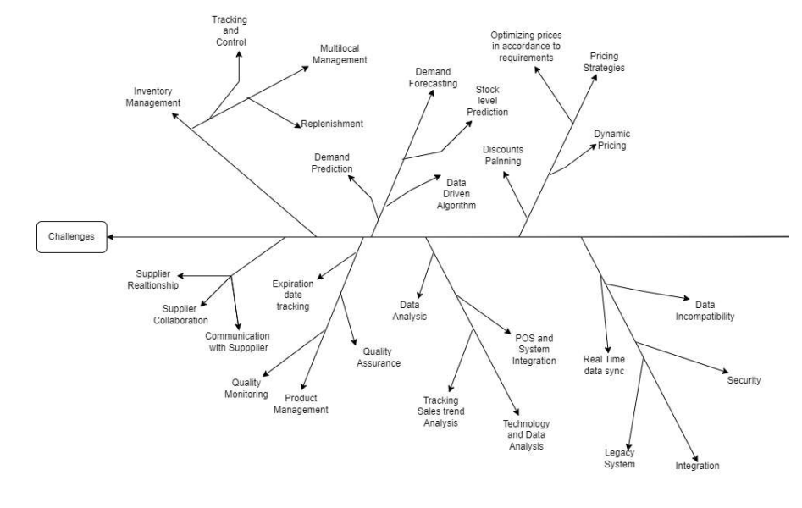

**2.3 User Classes and Characteristics**

The Perishable Management System is designed to accommodate a diverse range of user classes, each with distinct roles and responsibilities:

1. Store Managers:

- Responsibilities: Store managers are entrusted with the oversight of overall store operations and efficient inventory management.

- System Access: They are granted a high level of system access to enable them to make critical decisions, manage resources, and implement strategic changes.

2. Store Employees:

- Responsibilities: Store employees play a pivotal role in the day-to-day activities of the store, including tasks such as receiving, stocking, and selling perishable items to customers.

- Technical Proficiency: Their user characteristics generally include basic computer literacy, allowing them to effectively utilize the system for routine operations and transactions.

3. Suppliers:

- Responsibilities: Suppliers are integral collaborators within the system, providing essential product information and adhering to delivery schedules to maintain seamless supply chain operations.

- Technical Proficiency: Suppliers typically possess a moderate level of technical proficiency, ensuring they can interact efficiently with the system, exchange data, and facilitate smooth communication.

5. Administrators:

- Responsibilities: Administrators oversee system configurations, user access controls, and system maintenance. They ensure the system functions smoothly and securely.

- Technical Proficiency: Administrators possess a high level of technical expertise to manage system settings and troubleshoot issues effectively.

User characteristics within these classes may vary based on individual skills and experiences, but the system is designed to cater to this diversity. The goal is to provide a user-friendly interface that empowers all user classes to leverage the system effectively in their respective roles, ultimately contributing to the success of perishable goods management.

Context Diagram

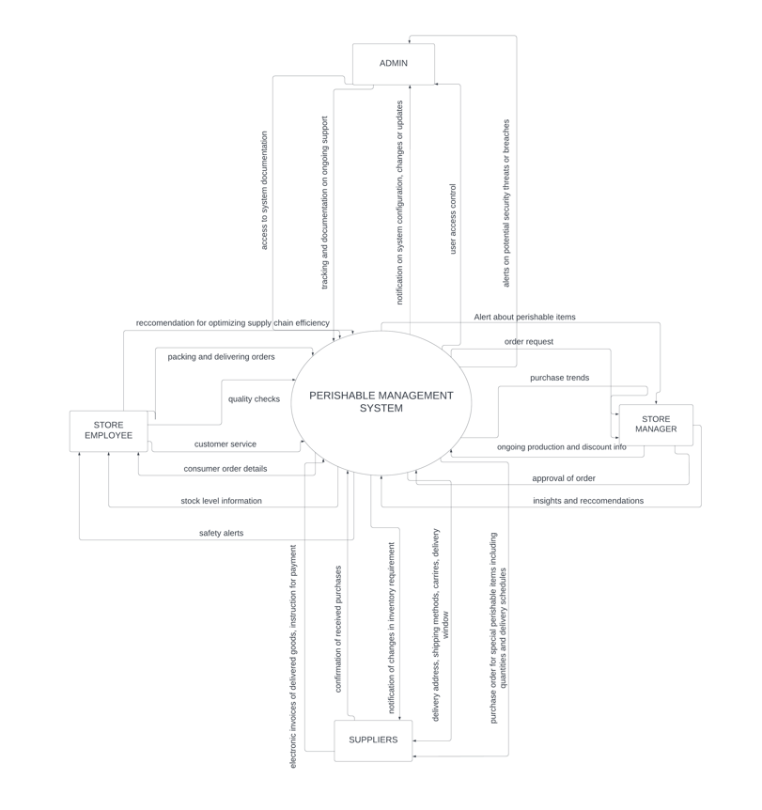

**2.4 Operating Environment**

The system will operate in the following environment:

- Hardware Platform: Windows-based servers for backend operations and desktop/laptop computers for user interfaces.

- Operating System: Windows Server for backend, Windows 10 for user interfaces.

- Software Components: Microsoft SQL Server for the database, for application development.

- Integration: Integration with existing hardware, including barcode scanners and receipt printers.

**2.5 Design and Implementation Constraints**

Constraints affecting the system design and implementation include:

- Regulatory Policies**:**Compliance with industry-specific regulations, such as food safety standards.

- Hardware Limitations: Meeting hardware requirements for optimal performance.

- Interfaces: Ensuring compatibility with existing POS systems.

- Security Considerations: Implementing encryption and access control measures.

- Design Conventions: Adherence to company coding standards and design conventions.

**2.6 User Documentation**

User documentation will include:

- User manuals for store managers and employees.

- On-screen help within the application.

- Video tutorials for basic system functionalities.

**2.7 Assumptions and Dependencies**

Assumptions:

- Third-party libraries and frameworks will be available for use.

- Adequate network infrastructure for data exchange with suppliers.

- Availability of accurate product data from suppliers.

Dependencies:

- The project depends on the timely delivery of product data from suppliers.

- Integration with external hardware devices relies on device availability and compatibility.

**3. External Interface Requirements**

**3.1 User Interfaces**

The user interface of the Perishable Management System is designed to be user-friendly and intuitive. It will consist of the following logical characteristics:

- Graphical User Interface (GUI): The system will feature a graphical interface with standard GUI controls such as buttons, text fields, drop-down menus, and data grids.

- Screen Layout: Screens will follow a consistent layout, with the main menu providing easy access to various modules, including Inventory Management, Demand Forecasting, Supplier Collaboration, and Quality Assurance.

- Standard Buttons and Functions: Common functions such as Save, Update, Delete, and Help will appear consistently across the application.

- Keyboard Shortcuts: Keyboard shortcuts will be provided for frequently used actions, enhancing user efficiency.

- Error Message Display: User-friendly error messages will be displayed in a standard format, including a description of the error and guidance on corrective actions.

- Sample Screen Images: See the attached document for sample screen images illustrating the user interface design.

**3.2 Hardware Interfaces**

The Perishable Management System will interact with the following hardware components:

- Barcode Scanners: The system will support barcode scanners for product identification during inventory management and sales processes.

- Receipt Printers: Receipt printers will be used for generating sales receipts.

- Scales: For weighing perishable items during inventory management.

- Desktop/Laptop Computers: The application will run on standard desktop and laptop computers, meeting minimal hardware requirements outlined in the system documentation.

**3.3 Software Interfaces**

The system will interface with the following software components:

- Database Management System: The Perishable Management System will interact with a Microsoft SQL Server database (version [Specify Version]) for data storage and retrieval.

- Operating System: The software will be compatible with Windows Server [Specify Version] for backend operations and Windows 10 for user interfaces.

- Third-Party Libraries: The application may utilize third-party libraries and frameworks for specific functionalities (e.g., charting libraries for demand forecasting).

- Integration with Existing Systems: The system will integrate with existing Point-of-Sale (POS) systems, and the details of this integration will be documented in a separate integration specification.

**3.4 Communications Interfaces**

The Perishable Management System will require the following communication interfaces:

- Email: The system may use email notifications for alerting store managers or suppliers about critical events or order status updates.

- Web Browser: Users will access the system via web browsers for certain functionalities, and the system will ensure compatibility with modern web browsers (e.g., Chrome, Firefox, Edge).

- Network Protocols: Communication between the client application and the server will use standard network protocols, such as HTTP/HTTPS for web-based interactions and TCP/IP for data transfer.

- Data Transfer Security: To ensure data security, HTTPS encryption will be employed for all web-based communications, and data transfer rates will be optimized to minimize latency.

This concludes the External Interface Requirements section of the SRS, detailing the logical characteristics of user interfaces, hardware and software interfaces, as well as communication interfaces for the Perishable Management System for Retail Stores. Specifics of user interface design and integration will be documented separately.

**System Features**

**4.1 Manage Perishable Inventory**

**4.1.1 Description and Priority**

Retail staff with appropriate permissions can add, edit, and remove perishable items from the inventory. This feature is critical for maintaining accurate stock levels and ensuring the quality of products. Priority = High.

**4.1.2 Stimulus/Response Sequences**

- Stimulus: Retail staff initiates the addition of a new perishable item.

- Response: System prompts the user to provide details like item name, category, expiration date, initial quantity, and supplier information.

- Stimulus: Retail staff update the quantity or information of an existing perishable item.

- Response: System displays the current details and allows the user to make necessary changes.

- Stimulus: Retail staff requests to remove a perishable item from the inventory.

- Response: If the item is not associated with any transactions, the system proceeds with deletion. Otherwise, it prompts the user to confirm archival.

**4.2 Set Expiry Notifications**

**4.2.1 Description and Priority**

The system provides notifications for approaching or expired perishable items. This helps retail staff to take timely action, such as markdowns or removal, to minimize waste. Priority = Medium.

**4.2.2 Stimulus/Response Sequences**

- Stimulus: System identifies a perishable item nearing its expiration date.

- Response: The system sends an email alert to designated staff members, providing details of the item.

- Stimulus: System detects a perishable item that has expired.

- Response: The system sends an immediate alert to designated staff members, with instructions for disposal.

**4.3 Quality Control Checks**

**4.3.1 Description and Priority**

Retail staff can conduct quality checks on perishable items. This ensures that products meet defined standards for freshness and appearance. Priority = High.

**4.3.2 Stimulus/Response Sequences**

- Stimulus: Retail staff initiates a quality check on a perishable item.

- Response: System prompts the user to enter observations and any necessary actions (e.g., marking as unsellable, requesting a replacement).

- Stimulus: Retail staff confirms the quality of a perishable item after a check.

- Response: The system updates the quality status of the item in the inventory.

**4.4 Track Supplier Information**

**4.4.1 Description and Priority**

The system allows for the recording and management of supplier information for perishable items. This includes contact details, delivery schedules, and performance ratings. Priority = Medium.

**4.4.2 Stimulus/Response Sequences**

- Stimulus: Retail staff adds a new supplier.

- Response: System prompts the user to input supplier details, such as name, contact information, and delivery schedule.

- Stimulus: Retail staff updates existing supplier information.

- Response: System displays current details and allows the user to make necessary changes.

**4.5 Generate Perishable Reports**

**4.5.1 Description and Priority**

Retail staff can generate reports related to perishable inventory, including stock levels, expiration dates, and supplier performance. These reports assist in decision-making and planning. Priority = High.

**4.5.2 Stimulus/Response Sequences**

- Stimulus: Retail staff requests a report on perishable stock levels.

- Response: The system generates a report displaying the current quantities of each perishable item.

- Stimulus: Retail staff requests a report on upcoming expirations.

- Response: The system generates a report listing perishable items with impending expiration dates.

**5. Other Nonfunctional Requirements**

**5.1 Performance Requirements**

**Performance Requirement 1: Response Time**

- The system shall respond to user queries and actions within a maximum of 2 seconds under normal operational load.

- Rationale: Ensures a responsive and efficient user experience, reducing waiting times during inventory management and sales operations.

**Performance Requirement 2: Scalability**

- The system should scale to support an additional 100 retail stores without degrading performance.

- Rationale: Accommodates future growth and expansion of the retail network.

**Performance Requirement 3: Data Retrieval Speed**

- The system shall retrieve and display inventory information within 1 second when queried by store employees.

- Rationale: Enhances productivity by quickly providing essential information during daily store operations.

**5.2 Safety Requirements**

**Safety Requirement 1: Temperature Monitoring**

- The system must continuously monitor temperature conditions in storage areas to ensure perishable items are stored within acceptable temperature ranges.

- Safeguards: In case of temperature deviations, the system shall immediately alert store employees to take corrective actions.

- Rationale: Prevents spoilage and ensures the safety of perishable products.

**Safety Requirement 2: User Access Control**

- The system must enforce strict user access control to prevent unauthorized access to sensitive data and functions.

- Safeguards: User authentication and role-based access control (RBAC) will be implemented.

- Rationale: Protects confidential data and ensures the integrity of the system.

**5.3 Security Requirements**

**Security Requirement 1: Data Encryption**

- All data transmissions between the client and server, as well as data at rest, shall be encrypted using industry-standard encryption protocols (e.g., TLS).

- Rationale: Protects sensitive data from unauthorized access during transmission and storage.

**Security Requirement 2: Audit Trail**

- The system must maintain an audit trail of all user activities, including login attempts, data modifications, and system access.

- Rationale: Enables traceability and accountability for system actions, aiding in security investigations.

**5.4 Software Quality Attributes**

**Quality Attribute 1: Maintainability**- The system's codebase shall follow industry best practices, coding standards, and be well-documented to facilitate easy maintenance and future enhancements.

**Quality Attribute 2: Usability**

- The user interface shall adhere to established usability principles and undergo usability testing to ensure ease of use.

- Rationale: Enhances user satisfaction and reduces training time.

**5.5 Business Rules**

**Business Rule 1: Inventory Updates**

- Only authorized store managers and employees can perform inventory updates and adjustments.

- Rationale: Enforces accountability and prevents unauthorized changes to inventory data.

**Business Rule 2: Supplier Orders**

- Store managers are responsible for placing supplier orders, and only authorized suppliers can confirm and fulfill these orders.

- Rationale: Ensures control over the ordering process and supplier interactions.

**6. Other Requirements**

These additional requirements cover aspects related to database management, internationalization, legal compliance, reuse objectives, and environmental considerations for the Perishable Management System for Retail Stores. They address specific needs and objectives that are important for the successful development and operation of the system.

**6.1 Database Requirements**

Database Requirement 1: Data Backup and Recovery

- The system shall implement regular automated database backups to ensure data integrity and provide the capability to restore the database to a previous state in case of data corruption or loss.

- Frequency of Backups: Daily backups.

- Retention Period: Backups shall be retained for a minimum of 30 days.

- Rationale: Data is a critical asset, and these measures ensure data availability and recoverability.

**6.2 Internationalization Requirements**

Internationalization Requirement 1: Multilingual Support

- The system shall support multiple languages to accommodate users from different regions.

- Supported Languages: Initially English and Spanish.

- Rationale: Enables the system to be used in diverse retail environments.

**6.3 Legal Requirements**

Legal Requirement 1: Compliance with Data Protection Regulations

- The system must comply with all relevant data protection regulations, including but not limited to GDPR (General Data Protection Regulation) and HIPAA (Health Insurance Portability and Accountability Act) where applicable.

- Rationale: Ensures legal and ethical handling of user data and protects user privacy.

Legal Requirement 2: Compliance with Food Safety Regulations

- The system must comply with food safety regulations applicable to the retail industry, ensuring proper handling and tracking of perishable goods.

- Rationale: Ensures the system aligns with industry-specific regulations and standards.

**6.4 Reuse Objectives**

Reuse Objective 1: Code Reusability

- The development team shall aim to maximize code reusability by modularizing components and following best practices for code organization.

- Rationale: Reduces development effort and maintenance costs for future enhancements.

**6.5 Environmental Requirements**

Environmental Requirement 1: Energy Efficiency- The system should be designed to be energy-efficient, especially in areas where energy conservation is a concern.

- Rationale: Reduces operational costs and environmental impact.